Laboratory work #4 Automatic light control
When you start New project tick 3D model and PCB layout. Assemble the circyit below. All elements areshown in the left side
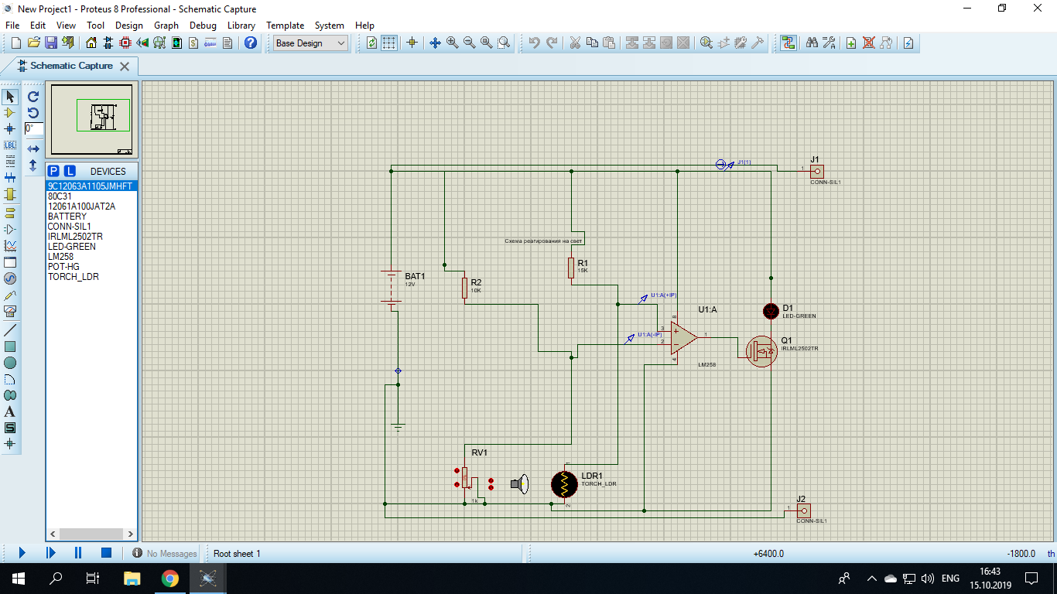
Assemble PCB
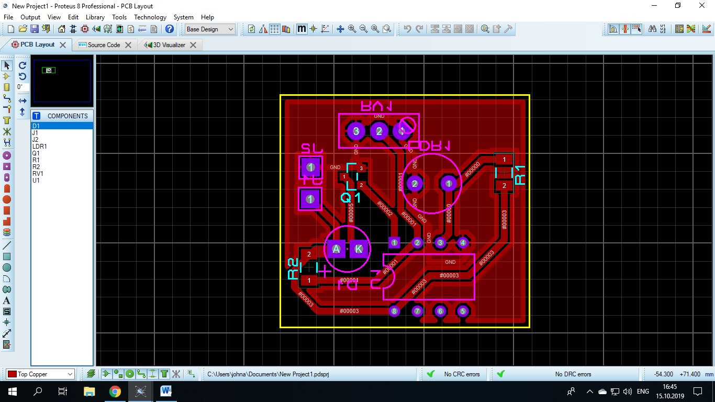

Show 3D model
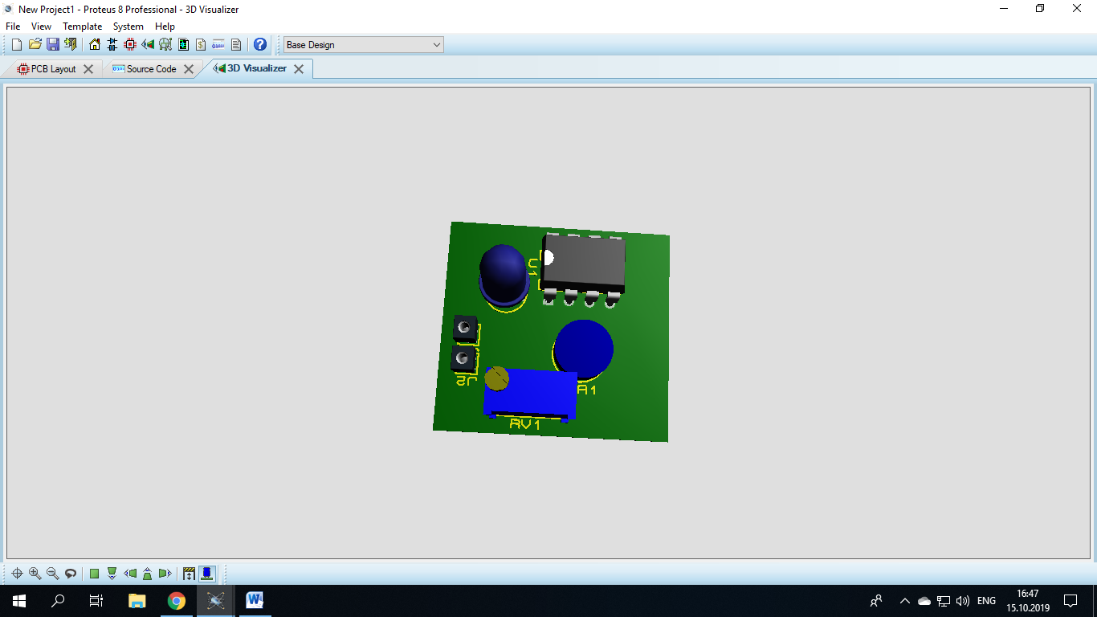
Questions:
- Why do we need OPAMP?
- How does photoresisitor work?
- Why do we need potentiometer?

